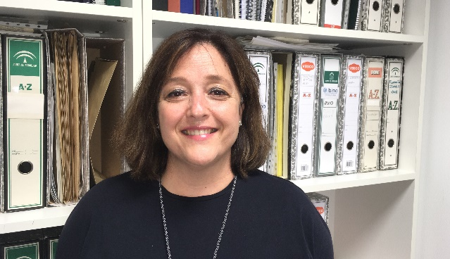After obtaining my PhD with Cum Laude distinction in 1994, I started working Allergy Specialist, becoming public employee in 2010. In 2014 I was selected Section Head, in 2016 Director of Unit, and in 2018 Allergy Service Director. I have managed to place the unit as one of the main alelrgy services at both national and international level, obtaining accreditation by the Andalusian Agency for Healthcare Quality, and becoming in 2018 Center of Excellence by the World Allergy Organization. Currently, there are only 21 centres with this ackowledgement worldwide. After several years as Associate Professor, I became Full Professor in 2019. I have mentored allergy resident medical interns since 2004 and directed 19 doctoral theses and 10 final degree projects. Along my career, I have performed several stays in prestigious research national and international centres. Besides, since 2015 I am spokesperson and since 2019 treasurer of the Official College of Doctors of Málaga, representing the university teaching staff. I am since 2017 coordinator of the Asthma, Allergic and Adverse Reactions network (ARADyAL). This is one of the 14 research networks granted by the Spanish Ministry of Economy. Moreover, I am coordinator of the research group Nanostructures for Diagnosing & Treatment of Allergic Diseases of the Andalusian Centre for Nanomedicine & Biotechnology (BIONAND) and of the Allergy research group of the Institute of Biomedical Research in Málaga (IBIMA). In the latter, I am coordinator of the research area Autoimmune diseases, infectious diseases, inflammation, and allergies and I have been Scientific Vicedirector. I have also been President of the Research Ethics Committee of Málaga. Currently, I am member of the Executive Committee of the European Academy of Allergy and Clinical Immunology (EAACI), and one of the 21 voting members from a total of 10,000 members from around 120 countries. I am also spokesperson of the Andalusian Society of Allergy and Clinical Immunology (AlergoSur). My main research area is drug and food allergy and immunotherapy. I have been principal investigator of 17 national competitive projects as collaborating researcher in more than 25 projects. Currently, I coordinate a work package of a Horizon 2020 European project, two JPI European projects, and one Euronanomed European project. I am author of more than 200 publications in international journals, of more than 300 communications to national and international congresses, and I have been invited speaker in more than 40 conferences. I have received 6 research awards. Besides, I have worked as reviewer for the journals with highest impact in the field of Immunology. Recently, I have been appointed as Deputy Editor of the Allergy journal, one the leading journals in the field of Allergy. I am also inventor of 9 patents, one of which has been licensed to the industry for diagnosing betalactam allergy. Finally, I have mentored more than 20 researchers.